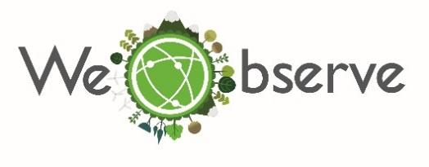
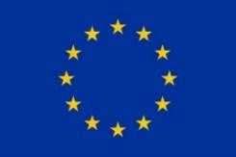

  - “An Ecosystem of Citizen Observatories for
  - Environmental Monitoring”

Athens, 15/06/2018
Dr. Angelos Amditis, ICCS
a.amditis@iccs.gr

WeObserve Communities of Practice launched their activities towards a sustainable Citizen Observatories ecosystem

The WeObserve Communities of Practice (CoPs) started paving the way for a sustainable Citizen Observatories (CO) ecosystem by launching their activities within the Citizen Science Workshop Day of the 2nd International ECSA Conference, on 6 June 2018 in Geneva, Switzerland.
The WeObserve CoPs, organized in the framework of the WeObserve H2020 project, will serve as a mechanism for exchanging knowledge, providing valuable information on key thematic topics as well as strengthening the knowledge base of Citizen Observatories. During dedicated sessions, the first three CoPs were kicked-off, covering the following topics:
Co-creating citizen observatories and engaging citizens (CoP1)
Impact and value of citizen observatories for governance (CoP2)
Interoperability and standards for citizen observatories (CoP3)
The main goal lies on the definition of potential barriers and incentives for citizen engagement, the delineation of the socio-economic and environmental impacts of citizen science to governance and the evaluation of applicability of open standards to citizen science data.
Uta Wehn from IHE Delft led the workshops for CoP1 and CoP2, while Joan Masó from CREAF led the workshop for CoP3. They first introduced WeObserve, explaining the key challenges of mainstreaming citizen science that WeObserve addresses: awareness, acceptability and sustainability. Subsequently, it was the participants’ turn to introduce themselves. The three launch workshops were successful, enabling cross fertilization and bringing together experts and stakeholders from different environmental disciplines. Each CoP identified sub-topics that need to be addressed, drafted CoP-specific objectives and identified activities that are linked to the WeObserve CoPs in order to streamline and coordinate CoP efforts.
In total, five CoPs are foreseen to be organized throughout the project period, offering the opportunity to various citizen science practitioners to participate in the consolidation of knowledge in the field of citizen science and to demonstrate the added value of citizen observatories.
Sign up for the WeObserve Communities of Practice and help us develop a citizen-powered ecosystem for environmental monitoring. Indicate your interest through the online registration form available here.

Editor’s notes
Short description: | WeObserve Project (full name: An Ecosystem of Citizen Observatories for Environmental Monitoring) is a Coordination and Support Action funded by the EU under H2020 Research and Innovation Programme that aims to move citizens science into the mainstream by building a sustainable ecosystem of citizens observatories and related activities. WeObserve specifically aims to develop five communities of practice to assess the current CO knowledge base and strengthen it to address future environmental challenges using CO-driven science. The WeObserve consortium will also extend the geographical coverage of the CO knowledge base to new communities and support the implementation of best practices and standards across multiple sectors. Moreover, WeObserve will reinforce links of ongoing COs with regional and global initiatives, including GEOSS, Copernicus and the UN Sustainable Development Goals (SDGs) and promote the uptake of information from CO-powered activities across various sectors and foster new opportunities and innovation in the sector of in-situ earth observation.
Starting Date: | 1 December 2017
Duration: | 36 Months
Total cost/ EC contribution: : | EUR 1.069.507,50 million
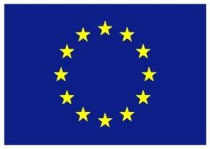
This project has received funding from the European Union’s Horizon 2020 research and innovation programme under grant agreement No 776740.
Coordinator: | International Institute for Applied Systems Analysis (IIASA)
Partners: | The 7 project partners are:  - International Institute for Applied Systems Analysis (IIASA), Austria  - IHE Delft Institute for Water Education (IHE-DELFT), Netherlands  - University of Dundee (UNIVDUN), United Kingdom  - Ecological and Forestry Applications Research Centre (CREAF), Spain  - Institute of Communication and Computer Systems (ICCS), Greece  - European Citizen Science Association(ECSA), Germany  - Autorita di Bacino dei Fiumi Isonzo, Tagliamento, Livenza, Piave, Brenta-Bacchiglione (AAWA), Italy
For more information:
Contact Us:  Steffen Fritz, Project Coordinator, IIASA (fritz@iiasa.ac.at)  Visit our Website: http://www.weobserve.eu/ | Join us on Social media:  - Facebook: @WeObserveEU  - Twitter: @WeObserveEU

